Subject | Body – English
December 6, 2022  Take Action for Self-Care #1: A Season of Many Colors  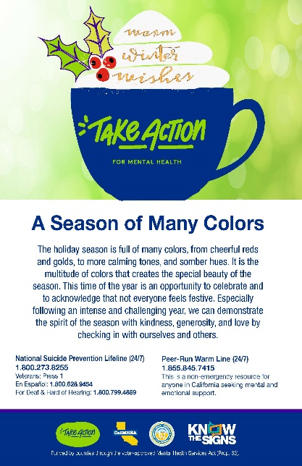  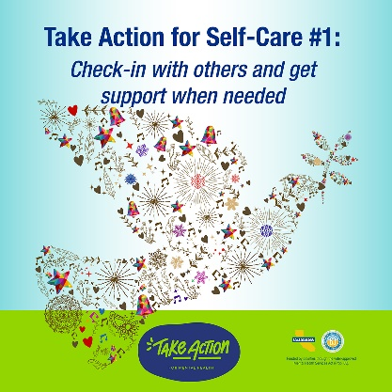 | Dear Colleagues,  The holiday season is full of many colors, from cheerful reds and golds, to more calming tones, and somber hues. It is the multitude of colors that creates the special beauty of the season. This time of the year is an opportunity to celebrate and to acknowledge that not everyone feels festive. Especially following an intense and challenging year, we can demonstrate the spirit of the season with kindness, generosity, and love by checking in with ourselves and others.  It's OK to not be happy. The holiday season is full of sights and sounds that can trigger symptoms of trauma, feelings of sadness, guilt, and shame because they are reminders of loss or vital things we do not have. When it seems like everyone else is swimming in joyful abundance, the contrast with how we are feeling can sharpen the pain. Even if we are fortunate enough to live in a comfortable home and be surrounded by helpful family, the increased presence of alcohol, rich foods, and more intense socializing can cause anxiety.  If you are feeling sadness or anger, ask yourself "what helps and what hurts"? Give a name to the things that trigger hard feelings and some thought to what makes you feel better. Simple things that can be found in everyday life are best, like taking a walk or ride outside, reading a favorite book, watching a beloved movie, or practicing deep breathing. If your feelings are overwhelming, you are not alone. It's OK to reach out to someone you trust.  It's also OK to be happy. Rejoice in these feelings and cultivate gratitude that you can feel them. Whatever you may have been through this year, you do deserve to celebrate and feel good. However, practicing balance and self-care is just as important when you are happy. Nothing will spoil feelings of happiness like overdoing it. Be sure to moderate intake of alcohol and food, incorporate movement every day, and get enough rest. If possible, reserve some quiet time for mindfulness practices, like deep breathing, and reflection.  How can you check-in with others who are having a tough time during the holiday season?  Expectations of festivity and togetherness make this time of year especially hard for those who may be alone, have lost a loved one, or are without a home or livelihood. In most cases these are not problems you can solve for them, but you can go out of your way with a small act of kindness. Acknowledge the unhoused person you meet on the street, ask them if you can buy them a coffee or a sandwich. In social gatherings or when checking in with friends and family be alert to signs that the person may be sad and open the door for them to share their feelings.  Take Action for Self-Care Challenge #1: Check-in with others and get support if needed.  National Suicide Prevention Lifeline (24/7)  1.800.273.8255  Peer-Run Warm Line (24/7)  1.855.845.7415

Subject | Body – English
December 13, 2022  Take Action for Self-Care #2: Listen to Music  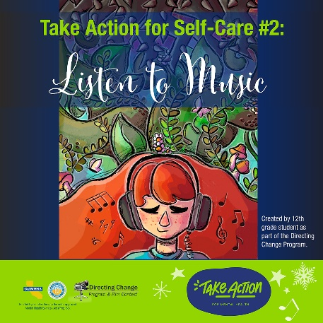 | Dear Colleagues,  Music is often the soundtrack to our lives – woven through life’s ups, downs and most memorable moments. A report from the Global Council on Brain Health (GCBH) found that music can have a positive effect on our emotional well-being, improving mood, decreasing anxiety and helping with management of stress.  It is no surprise then that many of us turn to music to cope through difficult times. This year as many students returned to school for in-person instruction, they found themselves facing new obstacles and stressors. To give students an outlet for these emotions, the Directing Change Program asked youth to create art that expressed their feelings about their return to school and how they were coping through the good, the bad, and the unexpected. A 12th grade student created a digital art piece about the power of music, saying “...music can take you to different worlds, somewhat becoming an escape from the stresses of reality. In my art piece I made a choice to make her hair red to represent the warm and comfortable feelings music makes one feel. The plants represent the music itself, taking over the thorns which represents negative thoughts or feelings. Music for many people including myself, is very therapeutic and is used as a form of self-care.”  Take Action for Self-Care Challenge #2: Listen to music.  Whether we use music to momentarily escape from daily life or as a tool to help us manage anxiety or stress, we can turn up the volume and let the music inspire, calm or energize us. Practice some music therapy today by listening to this original song from 12th grade student Malia J. Mislan submitted to the 2021 Hope and Justice contest, titled “At a Time”. https://vimeo.com/555814894.  To learn more about the Take Action for Mental Health campaign visit: www.takeaction4mh.com

Subject | Body – English
December 20, 2021  Take Action for Self-Care #3: Complete a Self-Care Assessment  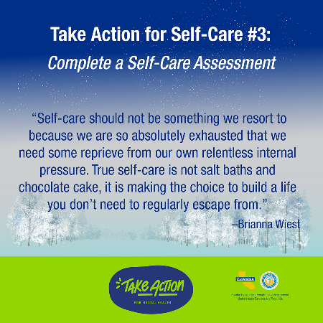 | Dear Colleagues,  As we wrap up one year and begin another, it is time to pause and remember to make time for self-care, not as an afterthought or a reward for checking items off on our to do list, but as a fundamental part of our daily routine.  Even the most passionate and committed people can become overwhelmed by a job, career or activity which they previously derived much of their purpose and fulfillment from. It can happen as the things that once inspired passion and enthusiasm are overshadowed by feeling run down and drained of physical or emotional energy. Maybe we notice that we have been harder and less sympathetic with people around us; maybe we have less patience and are more easily irritated by small problems; or maybe we don’t have the energy reserves to manage and bounce back from the larger problems.  With not enough time to do the things we need to get done, in our job and our personal lives, how can we possibly add something else into the mix? Self-care isn’t always adding something to our life but subtracting something can be powerful too. It is a critical part of the process of getting everything else done because it helps prevent burnout, reduces the negative effects of stress, and helps with focus and overall well-being.  In general, self-care falls into these domains: physical, emotional, spiritual, relationship, workplace/professional and overall balance.  Take Action for Self-Care Challenge #3: Complete a Self-Care Assessment.  This one can be downloaded from the University of Buffalo School of Social Work and their website offers a wide range of self-care tools and resources.  To learn more about the Take Action for Mental Health campaign visit: www.takeaction4mh.com

Subject | Body – English
January 3, 2022  Take Action for Self-Care #4: Check-in, Learn More & Get Support  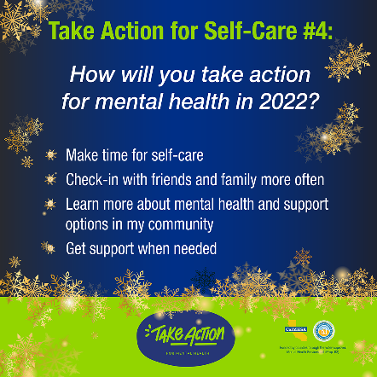 | Dear Colleagues,  What are your hopes for 2022? This is the question the Directing Change Program asked youth to reflect on through art, film and narrative.  One thing to place at the top of the resolution list is making time for self-care. Taking the time to intentionally care for our whole self – body, mind and soul – can keep us energized and mentally well in 2022. Self-care creates wellness not only for oneself but for the whole community around us.  Take Action for Self-Care Challenge #4: Consider taking action for mental health as part of your New Year’s resolutions and Check-in, Learn More & Get Support.  - Make time for self-care  - Check-in with friends and family more often  - Learn more about mental health, self-care practices, and support options available in your community  - Get support when needed and remember: You are not alone  And remember, real self-care has very little to do with “treating yourself” and a whole lot do with making choices for our long-term wellness every single day. Real self-care is about building habits that support our health and well-being. It’s making choices about where and how we spend our precious energy and time.  To learn more about the Take Action for Mental Health campaign visit: www.takeaction4mh.com

Subject | Body – English
January 10, 2022  Take Action for Self-Care #5: The Art of Gratitude  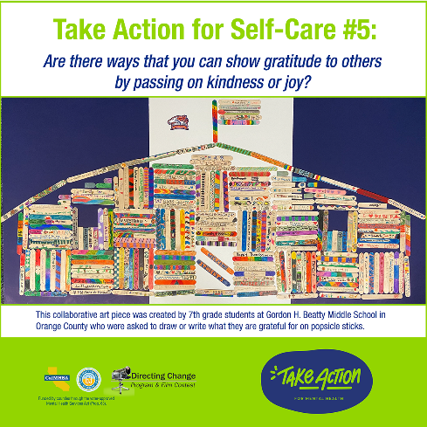 | Dear Colleagues,  Making time for self-care isn’t easy, especially when we’re busy and overwhelmed. Mindfulness can be a first step for anyone who struggles with self-care. While there is a very deep body of work to be explored and practiced for those who are interested (like Mindfulness Based Stress Reduction) experimenting with mindfulness is available to anyone.  A good place to start is to consciously shift our awareness to the smallest moments of joy we experience -a good laugh, a friendly hello, or feeling touched by a kind word or gesture. Research has found that small moments of positivity can accumulate over time and form new pathways in our brain. As a result, feelings of positivity and gratitude become easier the more we experience them.  Another starting point is to think about someone or something we are grateful for. The ways we show and practice gratitude can differ based on our culture, background, upbringing, and personalities. “Connective gratitude” is practiced in various cultures and occurs when we show gratitude in a meaningful and personalized way, thinking about how we can pass kindness to others. Though not the answer in every situation, gratitude can bring us closer together, giving us hope as we focus on something, or someone, that is going well.  Practicing gratitude is an important skill that can strengthen our relationships, and relationships are an important part of our self-care practice. This Self-Care Assessment asks us to think about our relationships. Do you schedule regular activity with your partner/spouse or your children? Do you make time to see friends? Do you stay in contact with relatives and faraway friends? Allow others to do things for you? Do you ask for help when you need it?  Take Action for Self-Care Challenge 5: Reflect on something or someone that makes your life better. Are there ways that you can show gratitude to others by passing on kindness or joy?  With all this in mind, the Directing Change Program asked youth to reflect on “the Art of Gratitude” through art, film and narrative in November 2021. We hope you will take a moment to draw inspiration from their creativity.  To learn more about the Take Action for Mental Health campaign visit: www.takeaction4mh.com
January 17, 2022  Take Action for Self-Care #6: Being Gentle with Ourselves  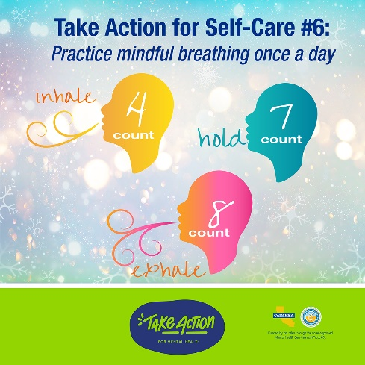 | Dear Colleagues,  Being gentle with oneself by setting boundaries and limits that support our mental health may be the most important self-care of all. As author Brianna Wiest says: “Self-care should not be something we resort to because we are so absolutely exhausted that we need some reprieve from our own relentless internal pressure. True self-care is not salt baths and chocolate cake, it is making the choice to build a life you don’t need to regularly escape from.”  Most of us experience any number of emotions from day to day. Experiencing negative emotions, especially when under stress, is part of the human experience; however, if left unprocessed or unacknowledged, they can cause harm physically and emotionally.  Research has found that breathing practices are effective at reducing stress, balancing our energy and emotions, and helping us process some of the more challenging feelings that can arise. Starting with small actions can be a good way to begin incorporating breathing into our self-care routine.  Take Action for Self-Care Challenge #6: Practice mindful breathing once a day.  For example, try out one of the breathing exercises below or mindful breathing, which has been known to reduce feelings of stress and anxiety.  Belly Breathing: When you breathe, your belly should expand, involving your diaphragm, a large muscle in your abdomen. This type of breathing is known as diaphragmatic, or belly breathing and can lower stress levels, reduce blood pressure, lower our heart rate, and help us relax. Download, share and watch the 30-second Belly Breathing Animation, which can be found here: https://www.suicideispreventable.org/social-media.php  4-7-8 Breathing Technique  Otherwise known as “relaxing breath”, 4-7-8 breathing, is a simple breathing exercise that can be done anywhere, anytime to aid in stress reduction, grounding, and even sleep. Inhale for a count of 7, hold for a county of 4, and then exhale for a count of 8! Download and share the 4-7-8 Breathing Card and Social Media post which can be found here.  To learn more about the Take Action for Mental Health campaign visit: www.takeaction4mh.com

