Thursday September 12: Developing Engagement Around Suicide Prevention

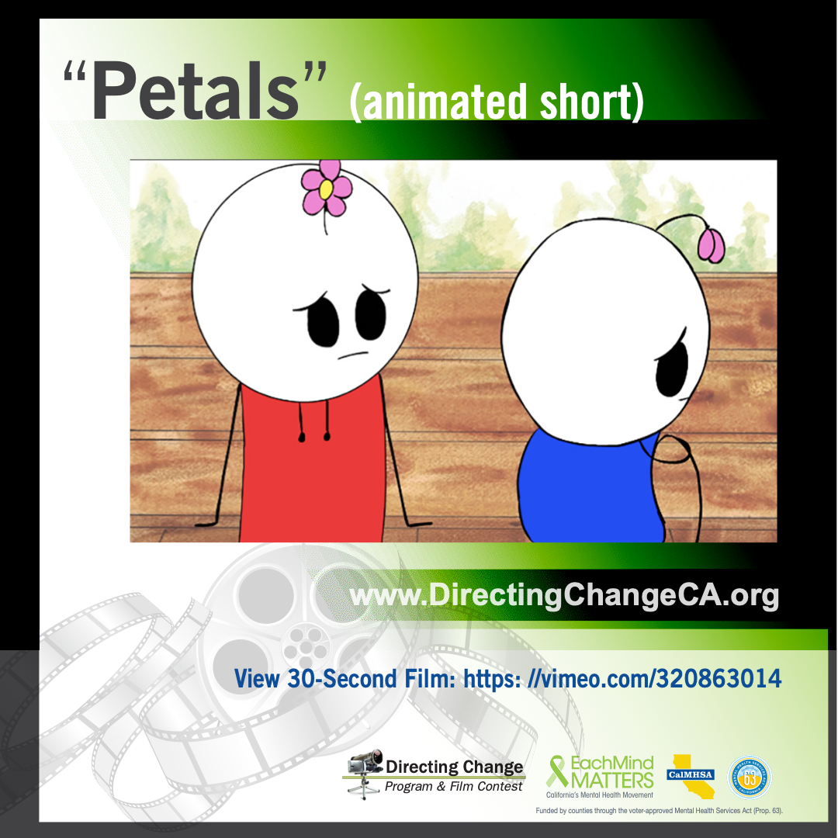

Suicide prevention is not a topic that should only be discussed once a year during awareness campaigns such as Suicide Prevention Week – but how do you keep up engagement after a day or weeklong campaign concludes?

If you work with youth, there are many activities that can be implemented both during Suicide Prevention Week and throughout the school year:
- Create a green ribbon campaign: Distribute ribbons for students to wear throughout the week, or encourage them to display them somewhere it can stay for a longer period of time, such as their backpacks or lockers. When students are asked about the ribbon, make sure they know that the lime green ribbon is a symbol of hope and shows that they are willing to be open about mental health/suicide prevention.
  - For a customizable, personalized touch, print out templates of green ribbons that students can decorate, label with their name, and write out one thing they can do to support suicide prevention at your school. Post the green ribbons in a central location to show how many students have made the pledge.
- Host a film screening to start conversations about suicide prevention and mental health. This can be held on campus during the day, at lunch time, or after school.
  - We suggest using some of the youth-created, youth-focused films about suicide prevention from the Directing Change Program to open up the dialogue. The top films of the past year are available for viewing and download here: http://www.directingchangeca.org/films/. You can also check out some of our personal favorite films from the past few years on our Suicide Prevention Films Handout: http://www.directingchangeca.org/wp-content/uploads/Best-of-Directing-Change-films-hand-out_Suicide-Prevention.pdf
- Encourage and support youth in creating Directing Change films: The Directing Change Program & Film Contest offers young people the exciting opportunity to participate in the mental health movement by creating 60-second films about suicide prevention and mental health that are used to support awareness, education, and advocacy efforts on these topics.
  - Learning objectives surrounding mental health and suicide prevention are integrated into the submission categories of the film contest, giving young people the opportunity to critically explore these topics. Program participants are exposed to appropriate messaging about these topics, warning signs, how to appropriately respond to someone in distress, where to seek help, as well as how to stand up for others who are experiencing a mental health challenge. To learn more visit: www.directingchangeCA.org.

For more ideas, review the Activity Tip Sheet available on the SPW 2019 resource page: https://www.eachmindmatters.org/spw2019/.

Highlighted Film: Petals
Created by Colin Kirkpatrick, Gabriel Gonzalez, Jade Sleiman, Monique Layseca & Eli Kupetz from Claremont High School, Tri-City (Los Angeles County)
- View film: https://vimeo.com/333581045
- The main character in this animated short faces feelings associated with suicide while on a walk with his friend. Little by little the friend starts losing the petals from his flower. The main character notices this and tries to support his friend and be there for him, as well as provide resources to his friend.

- Share the Film: Can you name some of the warning signs for suicide? This animated short shows a character recognizing signs in their friend and encourages the viewer to reach out https://vimeo.com/333581045 #SPWeek #directingchange #bethe1toknowthesigns #suicideprevention #warningsigns #bethe1to

Highlighted Film: Petals
Created by Colin Kirkpatrick, Gabriel Gonzalez, Jade Sleiman, Monique Layseca & Eli Kupetz from Claremont High School, Tri-City (Los Angeles County)
- View film: https://vimeo.com/333581045
- The main character in this animated short faces feelings associated with suicide while on a walk with his friend. Little by little the friend starts losing the petals from his flower. The main character notices this and tries to support his friend and be there for him, as well as provide resources to his friend.

- Share the Film: Can you name some of the warning signs for suicide? This animated short shows a character recognizing signs in their friend and encourages the viewer to reach out https://vimeo.com/333581045 #SPWeek #directingchange #bethe1toknowthesigns #suicideprevention #warningsigns #bethe1to

