Wednesday September 11: A Journey You Don’t Fight Alone

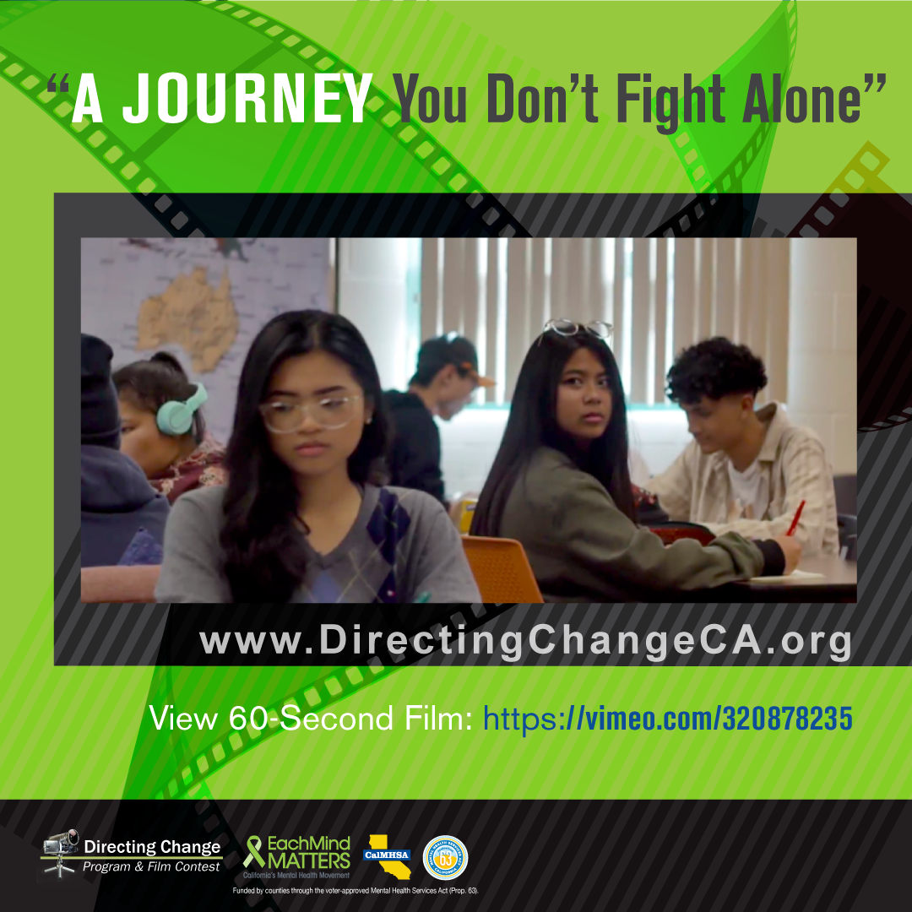

For many teens, the first person they reach out to about thoughts of suicide is a peer. Unfortunately, youth may feel detached from the way adults view and speak about the issue. Resources specifically about what to do when you are worried about a friend are available on our website: http://www.directingchangeca.org/wp-content/uploads/Howtohelpafriendfactsheet-1.pdf. This film covers what to do if you are worried that a friend has been thinking about suicide: https://www.youtube.com/watch?v=couOnev9FHc&feature=youtu.be.

Highlighted Film: A Journey You Don’t Fight Alone

Created by Tanaka Agere, Allysa Cabatingan, Gianna Barrantes, and Daniel Melgoza from Eleanor Roosevelt High School, Riverside County
- View film: https://vimeo.com/320878235
This film is narrated from the perspective of an individual who begins to notice depressive and suicidal behaviors from a struggling friend. With a desire to help and understand, the narrator seeks to communicate that the problem her friend faces is a journey meant to be fought with support and togetherness, not fought alone.

- Share the film: In times of crisis, we might feel like we can’t ask others to carry our burdens. This film tells the story of a girl reassuring her friend that the challenges we face are meant to be shared & not carried alone https://vimeo.com/320878235 #SPweek #directingchange #bethe1to #reachout #SuicidePreventionWeek2019

To view and download free educational resources, activity ideas, and films, visit: www.directingchangeCA.org or access the Each Mind Matters Suicide Prevention Week Activation Kit at https://www.eachmindmatters.org/spw2019/.

About Directing Change: The Directing Change Program & Film Contest is an evaluated youth engagement program. Directing Change engages students and young people throughout California to learn about the topics of suicide prevention and mental health by creating short films that are used to support awareness, education, and advocacy efforts on these topics. Youth apply knowledge about mental health and suicide prevention to create their own unique message about suicide prevention for their peers. Through the creative process of filmmaking young people are engaged via all methods of the learning spectrum: to see, experience, discuss, and apply. These students are recognized for their efforts at a red-carpet award ceremony and their films help impact social change at their schools and in their communities. Directing Change is part of Each Mind Matters: California's Mental Health Movement and statewide efforts to prevent suicide, reduce stigma and discrimination related to mental illness, and to promote the mental health and wellness of students. These initiatives are funded by counties through the Mental Health Services Act (Prop 63) and administered by the California Mental Health Services Authority (CalMHSA), an organization of county governments working to improve mental health outcomes for individuals, families, and communities.

