Tuesday, May 22

Suggested Email Subject Line: Supporting Youth Mental Health

Recent events in our country have motivated many youth to engage in activism in their communities, speaking out and inspiring others to take a renewed interest in the problems we face. While young people all over the country are getting involved and taking action, we can support them by reaching out, lending a listening ear, and sharing resources.

Whether they need help to heal, looking for support and connection, or simply need to be heard, trusted adults can help. Here are some ideas to engage and support the young people in your life:

- Encourage a school to start a NAMI Club on campus next school year.
- Share a Directing Change film on social media.
- Check out the Latinx LGBTQ+ Immigrant Youth Provider Fact Sheet and share it with other service providers who could benefit from the information.
- Support local Active Minds chapters and events during May is Mental Health Month.

Interested in how young people are getting involved in May is Mental Health Month? Each Mind Matters’ school mini-grantees are hosting a variety of activities to raise mental health awareness throughout the state, including a Stress, Depression, and Anxiety Awareness Gallery; Youth Mental Health Awareness Week; a communal Lunch on the Lawn event for Cultural and Mental Health Awareness; and a Stigma Pledge Wall.

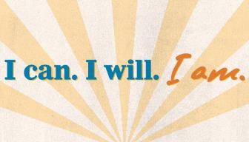

Remember to visit the (INSERT ORGANIZATION NAME) Facebook (INSERT HYPERLINK), Instagram (INSERT HYPERLINK), or Twitter (INSERT HYPERLINK) to learn about activities, ideas, and tips to promote mental health in your home and community.

[Insert Agency/CBO Signature Line]

